Wap to find the second hightest number in an array:

import java.util.Arrays;

public class Main {

public static void main(String args[]){

int array[] = {10, 20, 25, 63, 96, 57};

int size = array.length;

Arrays.sort(array);

System.out.println("sorted Array ::"+Arrays.toString(array));

int res = array[size-2];

System.out.println("2nd largest element is ::"+res);

}

}

Output:

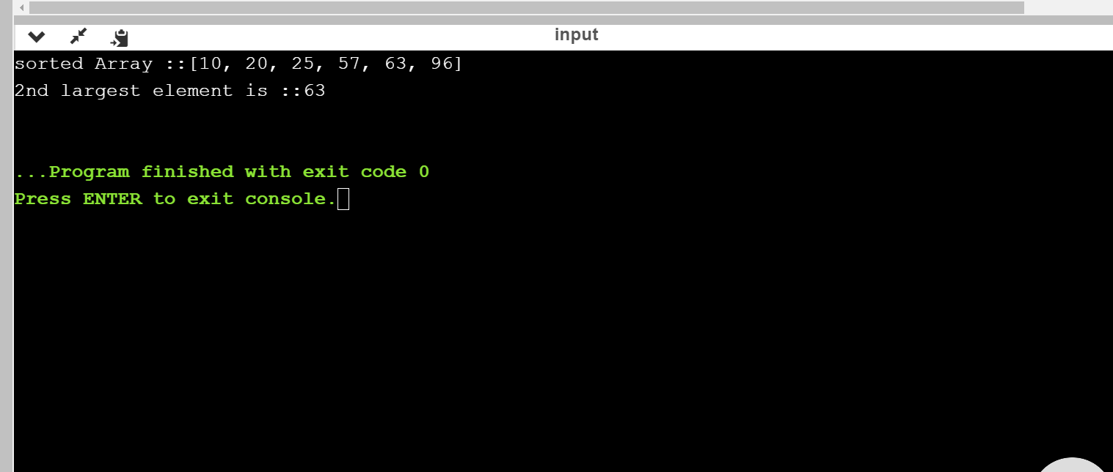

Wap to print all permutation of a given string:

public class PermuteString {

public static String swapString(String a, int i, int j) {

char[] b =a.toCharArray();

char ch;

ch = b[i];

b[i] = b[j];

b[j] = ch;

return String.valueOf(b);

}

public static void main(String[] args)

{

String str = "ABC";

int len = str.length();

System.out.println("All the permutations of the string are: ");

generatePermutation(str, 0, len);

}

public static void generatePermutation(String str, int start, int end)

{

//Prints the permutations

if (start == end-1)

System.out.println(str);

else

{

for (int i = start; i < end; i++)

{

//Swapping the string by fixing a character

str = swapString(str,start,i);

//Recursively calling function generatePermutation() for rest of the characters

generatePermutation(str,start+1,end);

//Backtracking and swapping the characters again.

str = swapString(str,start,i);

}

}

}

}

Output:

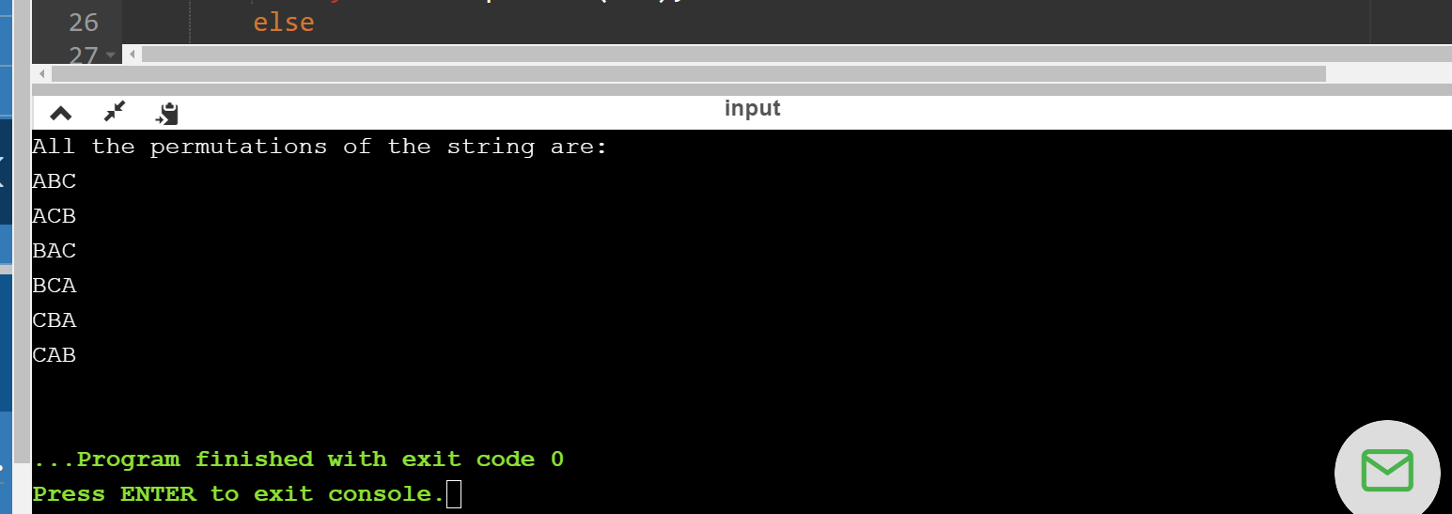

Wap to reverse a string without using string inbuit function:

import java.util.Scanner;

public class StringReverse {

public static String reverseString(String str){

if(str.isEmpty()){

return str;

}else{

return reverseString(str.substring(1))+str.charAt(0);

}

}

public static void main(String[] args) {

Scanner sc = new Scanner(System.in);

System.out.println("Enter a String value: ");

String str = sc.next();

String result = StringReverse.reverseString(str);

System.out.println(result);

}

}

Output: